Lab - 12: Graphical User Interface

Objectives:
Building Graphical User Interface (GUI) in MATLAB.
EXERCISE
1. Make a model in GUI that will calculate the first 5 harmonics of a sine wave, display the results in GUI.
CODE:
function sineWaveHarmonicsGUI
% Create a GUI window
fig = uifigure('Name', 'Sine Wave Harmonics', 'Position', [100, 100, 800, 500]);

% Add an input field for the fundamental frequency
uilabel(fig, 'Position', [20, 440, 200, 22], 'Text', 'Fundamental Frequency (Hz):', 'FontSize', 12);
freqInput = uieditfield(fig, 'numeric', 'Position', [230, 440, 120, 30], 'Value', 1, 'FontSize', 12);

% Add a button to calculate harmonics
calculateBtn = uibutton(fig, 'Position', [370, 440, 120, 30], 'Text', 'Calculate', 'FontSize', 12, ...
'ButtonPushedFcn', @(btn, event) calculateHarmonics(freqInput.Value, fig));

% Add a text area to display the results
uilabel(fig, 'Position', [20, 380, 200, 22], 'Text', 'Harmonics (Hz):', 'FontSize', 12);
resultArea = uitextarea(fig, 'Position', [20, 260, 360, 110], 'Editable', 'off', 'FontSize', 12);

% Add an axes for plotting
ax = uiaxes(fig, 'Position', [400, 50, 380, 350]);
title(ax, 'Harmonics', 'FontSize', 14);
xlabel(ax, 'Time (s)', 'FontSize', 12);
ylabel(ax, 'Amplitude', 'FontSize', 12);

% Nested function to calculate and display harmonics
function calculateHarmonics(fundFreq, figHandle)
if fundFreq <= 0
uialert(figHandle, 'Frequency must be positive!', 'Input Error');
return;
end
harmonics = fundFreq * (1:5); % Calculate first 5 harmonics
resultArea.Value = arrayfun(@(x) sprintf('Harmonic %d: %.2f Hz', x, harmonics(x)), 1:5, 'UniformOutput', false);

% Plot the harmonics
t = linspace(0, 1, 1000); % Time vector
combinedSignal = zeros(size(t));
hold(ax, 'off');
colors = lines(5); % Predefine colors for harmonics
for i = 1:5
harmonicSignal = sin(2 * pi * harmonics(i) * t);
combinedSignal = combinedSignal + harmonicSignal;
plot(ax, t, harmonicSignal, 'Color', colors(i, :), 'LineWidth', 1.5, 'DisplayName', sprintf('Harmonic %d', i));
hold(ax, 'on');
end
plot(ax, t, combinedSignal, 'k', 'LineWidth', 2, 'DisplayName', 'Combined');
legend(ax, 'FontSize', 10, 'Location', 'northoutside', 'Orientation', 'horizontal');
hold(ax, 'off');
end
end

RESULTS:
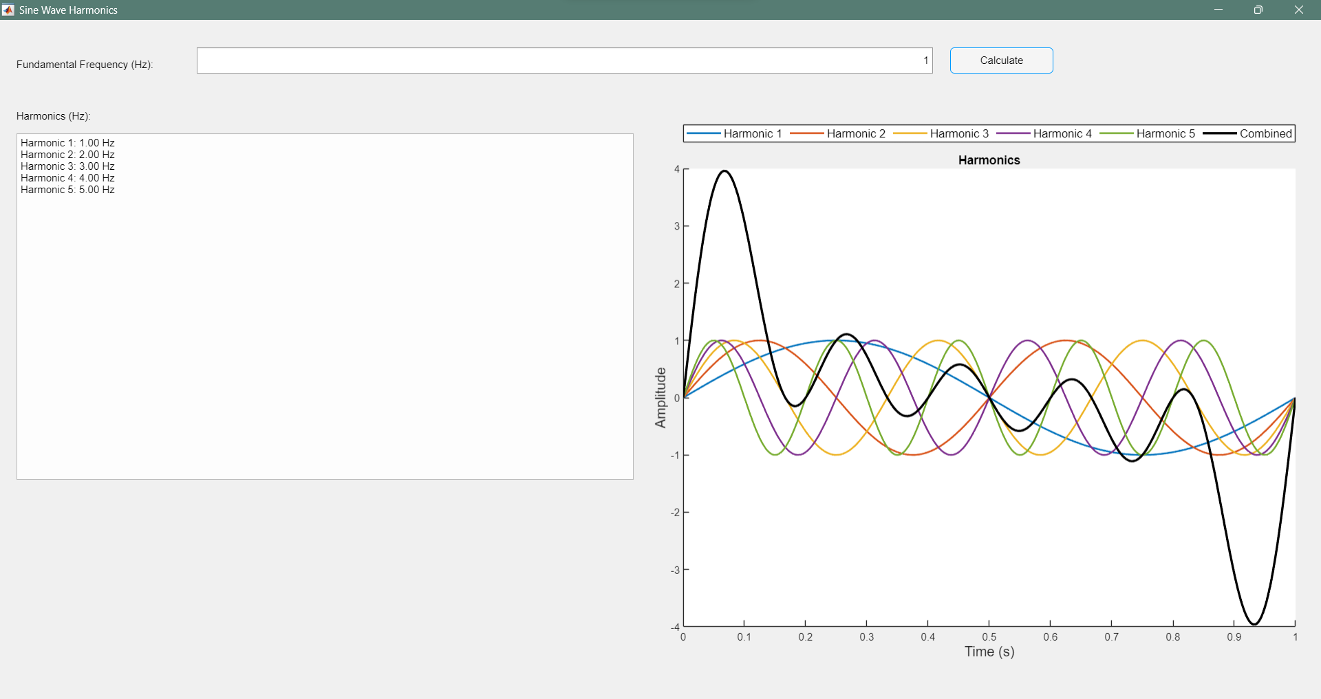

2. Make a model in GUI that will add up the harmonics of a sine wave and display a square wave. Input the wave from GUI and display the output in GUI. The output must be near a perfect square wave when more and more odd harmonics are added.
CODE:
function squareWaveHarmonicsGUI
% Create a GUI window
fig = uifigure('Name', 'Square Wave Approximation', 'Position', [100, 100, 800, 500]);

% Add an input field for the fundamental frequency
uilabel(fig, 'Position', [20, 440, 200, 22], 'Text', 'Fundamental Frequency (Hz):', 'FontSize', 12);
freqInput = uieditfield(fig, 'numeric', 'Position', [230, 440, 120, 30], 'Value', 1, 'FontSize', 12);

% Add an input field for the number of harmonics
uilabel(fig, 'Position', [20, 400, 200, 22], 'Text', 'Number of Odd Harmonics:', 'FontSize', 12);
harmonicsInput = uieditfield(fig, 'numeric', 'Position', [230, 400, 120, 30], 'Value', 1, 'FontSize', 12);

% Add a button to calculate the square wave
calculateBtn = uibutton(fig, 'Position', [370, 420, 120, 30], 'Text', 'Generate', 'FontSize', 12, ...
'ButtonPushedFcn', @(btn, event) generateSquareWave(freqInput.Value, harmonicsInput.Value, fig));

% Add a text area to display the results
uilabel(fig, 'Position', [20, 360, 200, 22], 'Text', 'Odd Harmonics (Hz):', 'FontSize', 12);
resultArea = uitextarea(fig, 'Position', [20, 260, 360, 90], 'Editable', 'off', 'FontSize', 12);

% Add an axes for plotting
ax = uiaxes(fig, 'Position', [400, 50, 380, 350]);
title(ax, 'Square Wave Approximation', 'FontSize', 14);
xlabel(ax, 'Time (s)', 'FontSize', 12);
ylabel(ax, 'Amplitude', 'FontSize', 12);

% Nested function to generate and display the square wave
function generateSquareWave(fundFreq, numHarmonics, figHandle)
if fundFreq <= 0 || numHarmonics <= 0
uialert(figHandle, 'Frequency and number of harmonics must be positive!', 'Input Error');
return;
end

oddHarmonics = fundFreq * (1:2:(2*numHarmonics-1)); % Calculate odd harmonics
resultArea.Value = arrayfun(@(x) sprintf('Harmonic %d: %.2f Hz', x, oddHarmonics(x)), 1:numHarmonics, 'UniformOutput', false);

% Plot the square wave approximation
t = linspace(0, 1, 1000); % Time vector
squareWave = zeros(size(t));
hold(ax, 'off');
colors = lines(numHarmonics); % Predefine colors for harmonics
for i = 1:numHarmonics
harmonicSignal = (1 / (2*i-1)) * sin(2 * pi * oddHarmonics(i) * t);
squareWave = squareWave + harmonicSignal;
plot(ax, t, harmonicSignal, 'Color', colors(i, :), 'LineWidth', 1.5, 'DisplayName', sprintf('Harmonic %d', 2*i-1));
hold(ax, 'on');
end
squareWave = (4 / pi) * squareWave; % Scale to approximate square wave amplitude
plot(ax, t, squareWave, 'k', 'LineWidth', 2, 'DisplayName', 'Square Wave');
legend(ax, 'FontSize', 10, 'Location', 'northoutside', 'Orientation', 'horizontal');
hold(ax, 'off');
end
end

RESULTS:
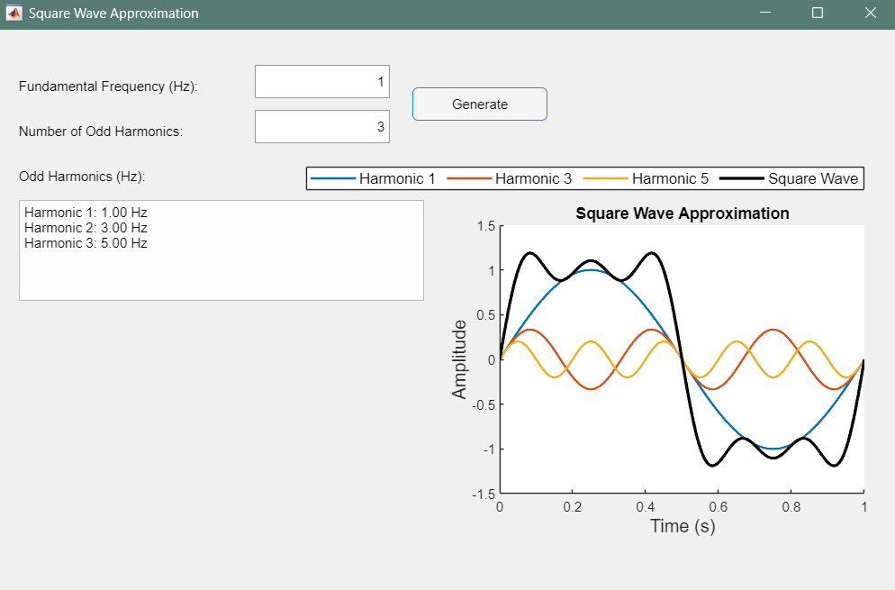

3. Record a statement in your voice: “I am taking a course in signals and systems”.Load this file in a GUI which plots the frequency spectrum of this speech signal.
CODE:
function speechSignalSpectrumGUI
% Create a GUI window
fig = uifigure('Name', 'Speech Signal Spectrum', 'Position', [100, 100, 800, 500]);

% Add a button to load the audio file
uibutton(fig, 'Position', [50, 440, 120, 30], 'Text', 'Load Audio', 'FontSize', 12, ...
'ButtonPushedFcn', @(btn, event) loadAudioAndPlot(fig));
% Add a label to display file details
fileInfoLabel = uilabel(fig, 'Position', [200, 440, 500, 30], 'Text', 'No file loaded', 'FontSize', 12);
% Add an axes for plotting the frequency spectrum
ax = uiaxes(fig, 'Position', [50, 50, 700, 350]);
title(ax, 'Frequency Spectrum', 'FontSize', 14);
xlabel(ax, 'Frequency (Hz)', 'FontSize', 12);
ylabel(ax, 'Magnitude', 'FontSize', 12);
% Nested function to load audio and plot the frequency spectrum
function loadAudioAndPlot(figHandle)
[file, path] = uigetfile({'*.wav;*.mp3'}, 'Select an Audio File');
if isequal(file, 0)
return;
end
filePath = fullfile(path, file);
% Read the audio file (supports MP3 using audioread)
try
[audioData, fs] = audioread(filePath);
catch
uialert(figHandle, 'Unsupported audio format. Please select a valid .wav or .mp3 file.', 'File Error');
return;
end

fileInfoLabel.Text = sprintf('Loaded: %s (Fs: %d Hz)', file, fs);
% Compute the frequency spectrum
n = length(audioData);
f = (0:n-1)*(fs/n); % Frequency vector
spectrum = abs(fft(audioData));
% Plot the spectrum
plot(ax, f(1:floor(n/2)), spectrum(1:floor(n/2)), 'b');
title(ax, 'Frequency Spectrum', 'FontSize', 14);
xlabel(ax, 'Frequency (Hz)', 'FontSize', 12);
ylabel(ax, 'Magnitude', 'FontSize', 12);
grid(ax, 'on');
end
end
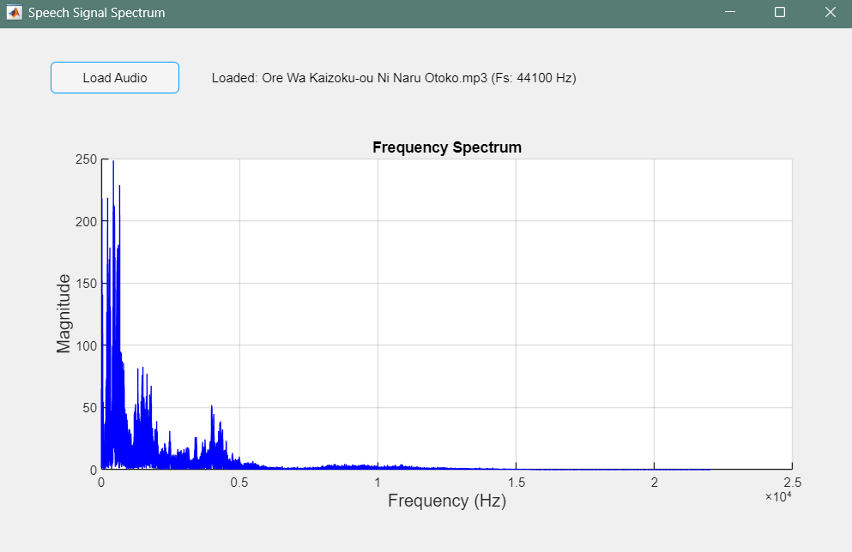
RESULT

